April 2022

Easter

Matters of Faith
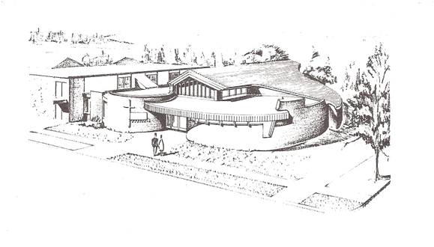

Faith United Church of Christ
1001 5th Street, PO Box 1113
International Falls, MN 56649
218-283-2486
Sunday Worship 1:00 p.m.

Pastor’s Ponderings

Since I've been a little kid I've loved spring! I remember sitting on the front porch in Sioux City, Iowa at age four enjoying the smell of the spring rain. And for many years of my childhood, watching thunderstorms in Nebraska and Iowa. I once saw “ball lightning” roll across the electrical wires outside of my grandparents house. Nature is amazing! I've always loved baby animals being born. I love planting, watching crops grow, and even weeding the garden!

Though we don't always get to wear dainty spring dresses to church for Easter up here in the north, Easter is still a sign of spring for sure. And within all these spring things I've been asking the kids about; like eggs, bunnies, chicks, lilies, and lambs; we can see the bigger message of Easter. We can see how all these modern symbols of spring connect to Jesus dying the most horrible death on a cross over two thousand years ago.

The bigger message is one of new life (bunnies, chicks, lambs), transformation (seeds, eggs), and growth (baby animals, crops). Even rain, symbolizing washing away the old and / or replenishing for new growth. So let's be mindful and think about these meanings as we continue to notice all the things that we love about spring. Whether from our childhood memories or what we currently appreciate the most about spring now; let's make these connections, and help our kids understand them too.

Blessings as we remember and prepare,
Pastor Kris

Update On The Survey

Thank you to everyone who participated in the recent church survey. We very much appreciate people sharing thier thoughts and views.

A total of 18 surveys were submitted. This is a good response considering the current size of our congregation.

A summary of the Pastoral Rating will be sent to the Parish for the Pastoral Relations committee review process.

The responses regarding the church will be carefully reviewed by the Council. This will take some time. Information coming from the survey data will be shared as it is ready.

And a Few More Notes…
Last Lenten Service at to be held at Zion Lutheran Church
at 7 pm on April 6th
~~~~~~~
Elephant Eaters – Next Meeting is 13th April 2022 at noon
Men’s Club 9 am on 14th March, 2022 at The Library Restaurant
~~~~~~~~
Reminder: Readers can pick up Scripture at noon on Wednesdays
~~~~~~~~
Anyone who would like a copy of the Financial Statement please contact the office by email or letter to receive one. Thank you!
~~~~~~~~
April Newsletter Deadline:
Please have info in by Wednesday, March 23rd (or sooner, if possible)

~~~~~~~~~

If you are receiving our Newsletter via mail (USPS), and would like to receive it through your email account instead, let the office know your email address. Call the office at 283-2486 (and leave a message if no one is working that day), drop a note on the secretary’s desk or drop a note in the mail to:
Faith United Church at:
PO Box 1113 International Falls, MN 56649

Faith United Church  1001 5th Street PO Box 1113 www.faithuccifalls.org  International Falls, MN  56649 | We’re on the Web!

