March 2022

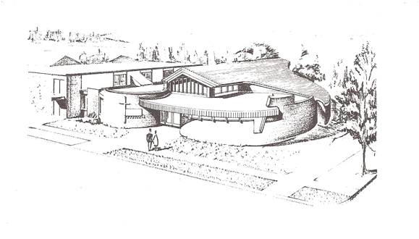
Matters of Faith

Faith United Church of Christ
1001 5th Street, PO Box 1113
International Falls, MN 56649
218-283-2486

Sunday Worship 1:00 p.m.

Pastor’s Ponderings

As we move into this Lenten season we are to pause and reflect. It is guided reflection for sure. The readings, music, and sermons on Sunday, as well as the suggestion to add something extra for six weeks, all lead our minds to the cross and what that means. The “extra” is to be something that will help us dig deeper into what Jesus went through during his last six weeks walking the earth. We might choose to have more time in prayer, start each day with a daily reading book, or join a Lenten Bible study or Wednesday church service.
We also need to be tying the message of Christ's life, death, and resurrection to what we are currently living; or should be. This idea of eternal life and of God's unconditional, unending love for each one of us is something that can affect our daily lives each and every day. Sometimes our Lenten music and litanies refer to preparing for Christ's crucifixion.
Years ago one of my kids asked me, “Mom, how come the church people pretend every year that they are just getting ready for Christ to die? He died over two thousand years ago!” I'd say we are remembering not pretending. And let's also remember this is 2000 + years later. We do know the rest of the story.
My hope is that by remembering this reality of the cycle of life/death/ resurrection each year, a new meaningful “something” jumps out at us year after year. Something that helps draw us closer and closer to the meaning of Jesus' life; the meaning of our own life. Something that helps us to better understand how important we are to helping God create heaven on earth.
The International Falls ecumenical clergy group will be providing a Wednesday evening Lenten service online through Zion Lutheran Church at 7 p.m. March 9th through April 6th. Please join us when you can.
Blessings as we remember and prepare,
Pastor Kris

Notes On The Attached Survey Regarding Faith United Church of Christ

The Parish is in the process of completing a review process as part of the contract with Pastor Kris. We are taking this opportunity to also ask for your feedback regarding Faith United Church of Christ.

We are asking for your response to a brief survey. We appreciate your feedback and thoughts regarding what you like and thoughts for how we can improve. Thank you for your time in completing the survey.

The survey will be sent be with the March newsletter. Paper copies will be available in the Narthex for your convenience as well. You are welcome to send your survey by email or you may leave it in a drop box in the Narthex.

The Council will review the responses and seriously consider how we can use this information to be the best we can be.

The feedback regarding the Pastor will be compiled and shared with the Parish for the Parish review.

Thank you for your time and thoughts. Please return your completed survey by Sunday, March 13th.

And a Few More Notes…
Lenten Services at to be held at Zion Lutheran Church
at 7 pm on the following dates:
March 9th, 16th, 23rd, 30th and April 6th
We are hosting the service on the 23rd
~~~~~~~
Elephant Eaters – Next Meeting is 9th March 2022 at noon
Men’s Club 9 am on 10th March, 2022 at The Library Restaurant
~~~~~~~~
Reminder: Readers can pick up Scripture at noon on Wednesdays
~~~~~~~~
Anyone who would like a copy of the Financial Statement please contact the office by email or letter to receive one. Thank you!
~~~~~~~~
April Newsletter Deadline:
Please have info in by Wednesday, March 23rd (or sooner, if possible)

~~~~~~~~~

If you are receiving our Newsletter via mail (USPS), and would like to receive it through your email account instead, let the office know your email address. Call the office at 283-2486 (and leave a message if no one is working that day), drop a note on the secretary’s desk or drop a note in the mail to:
Faith United Church at:
PO Box 1113 International Falls, MN 56649

Norwegian Medical Dictionary

Artery - Study Of Paintings Medical Staff- Doctor's Cane
Bacteria- Back Door to Cafeteria Morbid- Higher Offer

Barium - What Doctors Do When Nitrate- Cheaper Than Dayrate
Treatment Fails
Bowel- Letters Like A,E,I,O,U Node- Was Aware of
Caesarian Section- District in Rome Outpatient- Person Who Has
Fainted
Catarrh- Stringed Instrument Pelvis- Cousin of Elvis
Cat Scan- Searching For Kitty Post Operative- Letter Carrier
Cauterize- Made Eye Contact With Her Prostate- lat On You Back
Colic- A Sheep Dog Protein- Favoring Young People
Coma- A Punctuation Mark Recovering Room- Place to do
Upholstery
Congenital- Friendly Rectum- Dang Near Killed'em
D&C- Where Washington is Rheumatic- Amorous
Diarrhea- Journal of Daily Events Scar- Rolled Tobacco Leaf
Dilate- To Live Long Secretion- Hiding Anything
Enema- Not a Friend Seizure- Roman Empoer
Fester- Quicker Serology- Study of Knighthood
Fibula- Small Lie Tablet- Small Table
G.I. Series- Soldier's Ball Game Terminal Illness- Sickness at the Airport
Grippe- Suitcase Tibia- Country in N. Africa
Hangnail- Coat hook Tumor- An Extra Pair
High Colonic- Jewish Religious Urine- Opposite of “You're
Holiday Out”
Impotent- Distinguished, Well known Varicose- Located nearby
Intense Pain- Torture in the Teepee Vein- Conceited
Labor Pain- Getting Hurt at Work

Faith United Church We’re on the Web!
1001 5th Street Visit us at:
PO Box 1113 www.faithuccifalls.org
International Falls, MN
56649 Find Us On Facebook!
"Thank you for following Faith United UCC on Facebook"

https://www.facebook.com/Faith-United-Church-UCC-139667845839

And don’t forget to become a fan!

Phone: 218-283-2486
Email: faithuccifalls@gmail.com

Matters of Faith is published by Faith United Church, UCC for its members and friends

